**Project Write-up**

DESCRIPTION

**Project objective:**

As a developer, write a program to search a string entered by a user from the array of strings.

**Background of the problem statement:**

You have an array of email IDs of employees. As a programmer, write a program to search the email ID entered by a user.

**Validation of an Email ID .**

**package Validation_Of_Email;**

**import java.util.ArrayList;**

**import java.util.List;**

**import java.util.Scanner;**

**import java.util.regex.Matcher;**

**import java.util.regex.Pattern;**

**public class ValidationOfEmail {**

**public static boolean isValidEmail(String email) {**

**String regex = "^(.+)@(.+)$";**

**//initialize the Pattern object**

**Pattern pattern = Pattern.compile(regex);**

**Matcher matcher = pattern.matcher(email);**

**return matcher.matches();**

**}**

**public static void main(String[] args) {**

**List<String> emails = new ArrayList<String>();**

**// valid email addresses**

**emails.add("Ramram@example.com");**

**emails.add("Harihiohm@example.com");**

**emails.add("nandri@example.me.org");**

**//invalid email addresses**

**emails.add("asifa.example.com");**

**emails.add("akhanda..balayya@example.com");**

**emails.add("JaiNTR@.example.com");**

**for (String value : emails) {**

**System.out.println("The Email address " + value + " is " + (isValidEmail(value) ? "valid" : "invalid"));**

**}**

**System.out.println("Enter any email address to check");**

**Scanner sc = new Scanner(System.in);**

**String input = sc.nextLine();**

**System.out.println("The Email address " + input + " is " + (isValidEmail(input) ? "valid" : "invalid"));**

**}**

**}**

**Output:**

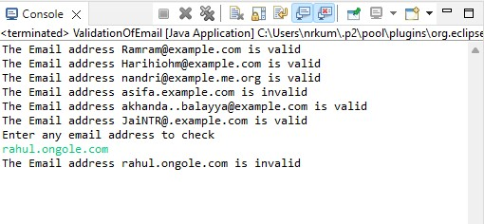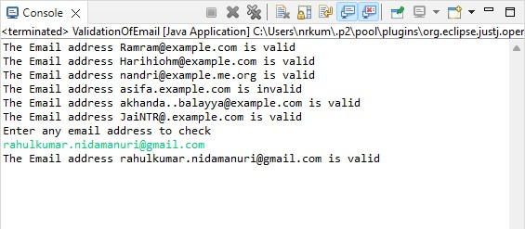

Pushing the code to your GitHub repositories

* Open your command prompt and navigate to the folder where you have created your files.

**cd <folder path>**

* Initialize your repository using the following command:

**git init**

* Add all the files to your git repository using the following command:

**git add .**

* Commit the changes using the following command:

**git commit . -m “Changes have been committed.”**

* Push the files to the folder you initially created using the following command:

**git push -u origin master**